**Silesian University of Technology**

**Hierarchical Control Lab-1**

**Title of the exercise:**

|  |
| --- |
| “Stirred-Tank Continuos-Flow reactor”  **Date of the exercise:**  25.10.2013. |

**Group Students:**

Ismail Kalay

Aiganym  Kadrina

**Introduction:**

The aim of the exercise is modeling of a stirred-tank continuous-flow reactor, finding its static characteristics, and designing control system for the reactor.

**Task 1:** For given parameters, using Matlab-Simulink software, create model of the reactor.

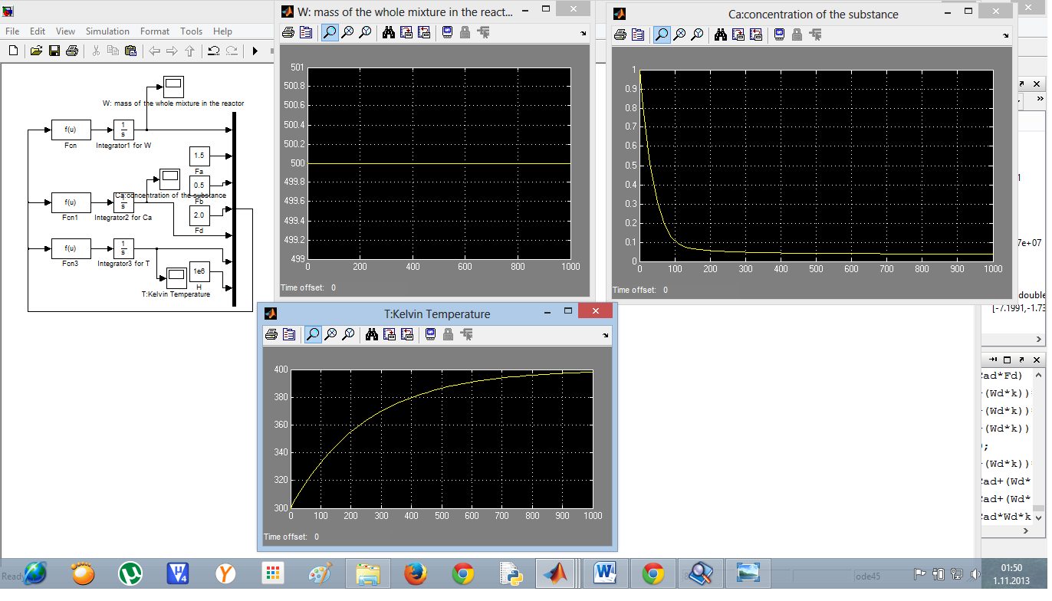

**Task 2:** Assuming constant values of (assured by input and output flows

satisfying an equation) calculate steady state values of Ca and T .

**main.m**

u=fsolve('lab1code2',[35 1100000]);

% u=fsolve('lab1code',[0.1 390]);

u(1), u(2)

**lab1code.m**

function y = f1(x)

Fa = 1.5;Fb = 0.5;Fd = 2.0;

Ta = 300;Tb = 300;

H = 10^6;h = 500;c = 5000;W = 500;

Ca = x(1);T = x(2);

k = 0.2*(1 - exp(1 - (T / 273)));

y(1) = ((((1 - Ca) / W)*Fa) - ((Ca / W)*Fb) - (Ca*k));

y(2) = ((((Ta - T) / W)*Fa) + (((Tb - T)/W)*Fb ) + (H / (c*W)) - ((h / c)*Ca*k));

%u=[0.0383 399.9288]

%u(1)=Cass;u(2)=Tss;

end

**Task 3:** Assuming constant values and calculate steady state values of Fd and H from Balance Equations.

**lab1code2.m**

function y = f2(x)

global Td Cad;Cad=0.05;Td=400;

Fa = 1.5;Fb = 0.5;

Ta = 300;Tb = 300;

h = 500;c = 5000;Wd = 500;

Fd = x(1);H = x(2);

k = 0.2*(1 - exp(1 - (Td / 273)));

y(1) = (Fa - (Cad*Fd) - (Wd*Cad*k));

y(2) = ((c*Fa*Ta) + (c*Fb*Tb) - (c*Fd*Td) + H - (h*Wd*Cad*k));

%u=[-7.1991e+000 -1.7397e+007]

%u(1)=Fdss;u(2)=Hss;

end

Note: using “fsolve” y(1)=0=equation1.Steady-state value of left-hand side equals 0 because derivative of constant is 0.

**Conclusions:**

Whenwe compare steady-state value of Ca and T with Simulink(for Simulation Stop Time =1000) and Matlab code(fsolve), we see that the values are nearly same.

Simulink Ca=0.0387, Simulink T=398.0969

fsolve Ca= 0.0383, fsolve T=399.9288